**SYNOPSIS**

**Book-A-Seat: Brigade School Events**

The project is aimed at making booking seats for events at the MLR Convention Centre for parents of the students at The Brigade School online and hassle-free via a website. The website will also provide occupancy details to the school and help prevent overbooking.

On logging in to the website with their child's Unique Student Number and password, the parents can select the event to book from a list of upcoming events. They can then select two available seats from the floor plan of the Convention Centre. The parents will receive a ticket complete with a QR code to be scanned for verification at entry which will go to their registered email id.

Python, Html and CSS with Django Framework and MySQL databases will be used to make the website.

The backend will require a server with databases and strong processing power. The front end will require a connection to the internet with a web browser.

**References and Inspirations:**

BookMyShow.com

The Brigade Schools Intranet

**Team members:**

**Aditi Vignesh**

**Suraj Acharya**

**Nafisa S Chanasmawala**

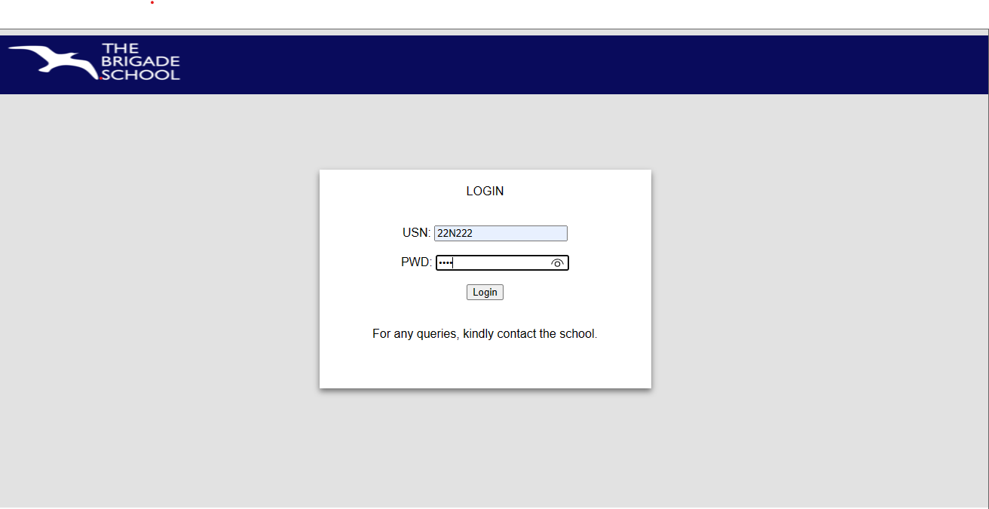

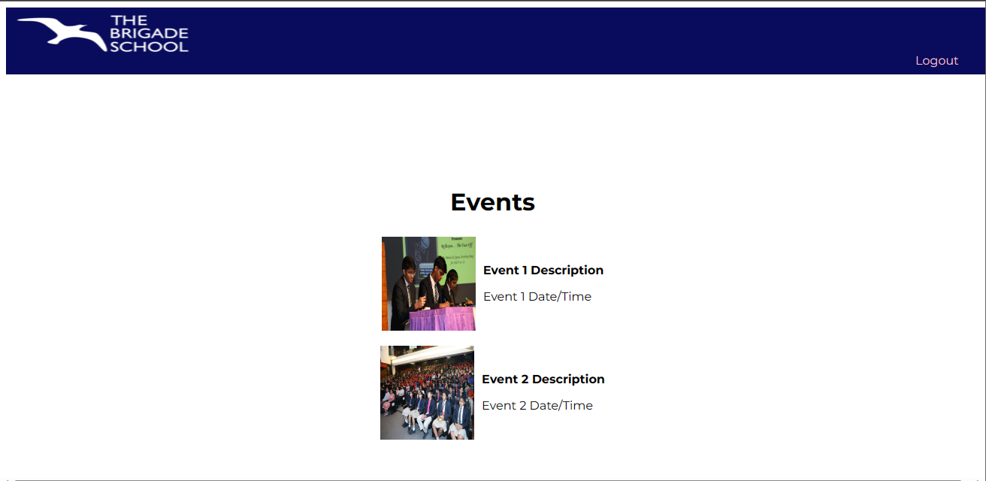

Images in the above web page are place holders which can be replaced with suitable picture for the corresponding event

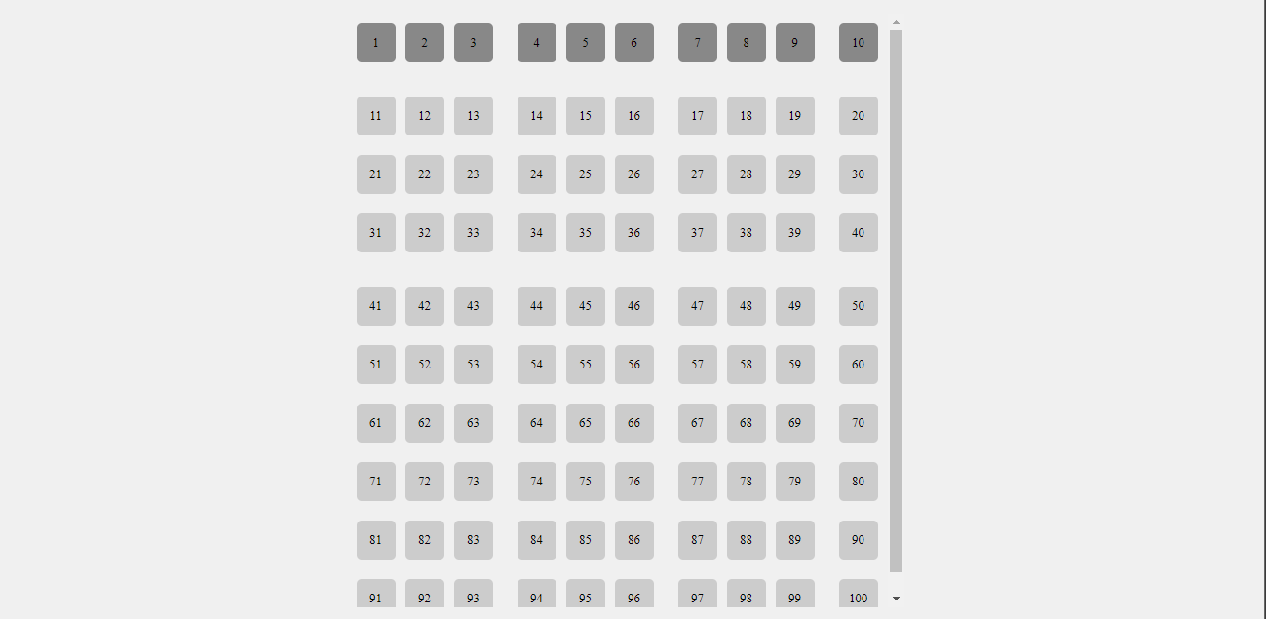

The layout of the seats will be changed in accordance to the seating arrangements of the Convention Centre.